25 Fun Ways to Practice Sight Words & Letters
1. Play Dough Words - use play dough to form letters to spell out each word.
2. Pipe Cleaner Words - use pipe cleaners and bend and form to make letters used to write out the words.
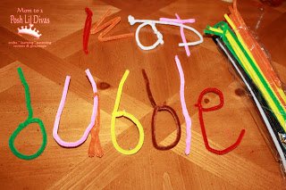
3. Stamp It! - use alphabet stamps and ink pads to stamp out words or let child use fingerprints to write words if you don't have letter stamps.
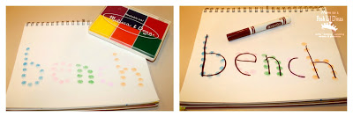
4. Paint It! - use a paintbrush and paint to spell words.
5. Finger Paint - get messy and have some sensory fun and finger paint to spell their words
6. Reverse Chalk Writing (aka Water Writing) - an easy and fun twist on writing words on the chalkboard. Use chalk to cover the chalkboard and have your child use a paintbrush dipped in water to write their words over it.
7. Type It! - Kids love getting computer time, so let them type their Word Wall words on the computer/ipad/lap top.
8. Rainbow Words – write words using different colored markers or crayons for each letter.

9. Trace - have fun and let kids trace their words on your back or palm. Have them focus on properly forming each letter so you can feel it being drawn.
10. Sidewalk Chalk (or Paint with Water) - go outside and spell your words using sidewalk chalk or paintbrushes and water.
11. Shaving Cream - This is another fun sensory experience! Make a thin layer of shaving cream on a tray and use a paintbrush or better yet a fingertip to spell out the words.
12. Trace in the Air - watch as children trace the letters in the air to spell each word.
13. Letter Beads - use alphabet letter beads and pipe cleaners to build words
14. Alphabet Stickers - build words using ABC stickers
15. Small/Medium/Large Words - How boring is it to write words 3 or 5 times each? How about jazzing it up by having kids write the word using the smallest letters they can possibly write (this one is a fave), then doing it normal sized and finally jumbo sized. It makes tedious writing practice so much more fun.
16. Build a Word with Legos - using some tape write each word (or letter) ahead of time on some legos. Call out a word and build until you have a sight word tower!
17. Q-Tip Writing - Use q-tips and paint to dot letters to spell the word or write the word using the q-tip as a paint brush.
18. Marble Words – Use flat bottom decorative marbles to form the letters needed to spell words.
19. Coffee Filters & Markers - let your child write the words using markers on coffee filters. Once you are all done, hand them a spray bottle of water and let them turn their word practice into art!
20. Hidden Words - on a white piece of paper let your child write out the spelling words using a white crayon. Once all words have been written use watercolors and paint to make hidden words appear.
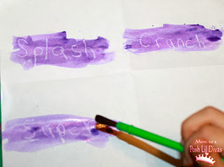
21. Print Words - Use newspaper or magazine print to cut out fun letters. Have child make words using clipped letters.
22. Novelty Erasers - use small erasers to spell words
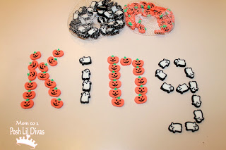

23. Flashlight Words - set up an Alphabet chart, turn out the lights and use a flashlight to shine on each letter (one letter at a time) to spell words.
24. Craft Stick Spelling - write the necessary letters on craft sticks, mix them up and have child build words using the appropriate sticks.
25. Pudding Practice - spread out a spoonful of pudding on a piece of wax paper and practice writing words or letters with your finger. Yum!

